Roller coaster and circular motion

Technical University of Cluj-Napoca, Cluj-Napoca, Romania
E-mail:

Abstract. When students heard of physics, they often think that it is a subject without applicability. Well, looking deeper, we could notice that everything around us involve this subject. I bet everyone have heard about roller coasters, but have you ever thought about the physical phenomena it involves? In this article I prove that the physics behind roller coasters comes down to analysing the movement of the “train” in every critical position it has during its movement. Using certain examples, it can be noticed that the movement of the roller coasters is based on physical laws. After this analyse the general idea that the reader should assume is that: a roller coaster has no engine or power source of its own and for most of the ride, the train is moved by gravity and momentum.

1. Introduction
Roller coasters have a long and fascinating history. The direct ancestors of roller coasters were monumental ice slides - long, steep wooden slides covered in ice, some as high as 70 feet - that were popular in Russia in the 16th and 17th centuries
The first American roller coaster was the Mauch Chunk Switchback Railway, built in the mountains of Pennsylvania in the mid-1800s. The track, originally built to send coal to a railway, was reconfigured as a "scenic tour." For one dollar, tourists got a leisurely ride up to the top of the mountain followed by a wild, bumpy ride back down. Over the next 30 years, these scenic rides continued to thrive and were joined by wooden roller coasters similar to the ones we know today. These coasters were the main attraction at popular amusement parks throughout the United States.

With the Great Depression and World War II, roller-coaster production declined, but a second roller-coaster boom in the 1970s and early 1980s revitalized the amusement-park industry. This era introduced a slew of innovative tubular steel coasters. Some of the most popular ride variations, such as the curving corkscrew track.

2. Roller coaster components

At first glance, a roller coaster (Figure 1) is something like a passenger train. It consists of a series of connected cars that move on tracks. But unlike a passenger train, a roller coaster has no engine or power source of its own. For most of the ride, the train is moved by gravity and momentum. To build up this momentum, you need to get the train to the top of the first hill (the lift hill) or give it a powerful launch.
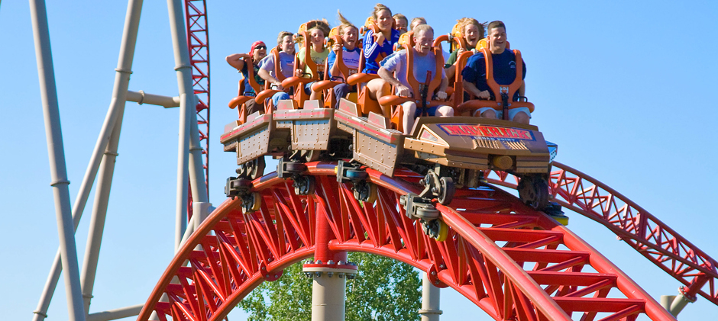
Like any train, a roller coaster needs a brake system so it can stop precisely at the end of the ride or in an emergency. In roller coasters, the brakes aren't built into the train itself; they're built into the track. This system is very simple. A series of clamps is positioned at the end of the track and at a few other braking points. A central computer operates a hydraulic system that closes these clamps when the train needs to stop. The clamps close in on vertical metal fins running under the train, and this friction gradually slows the train down.
Figure 1

At its most basic level, this is all a roller coaster is -- a machine that uses gravity and inertia to send a train along a winding track.

3. Roller coaster physics

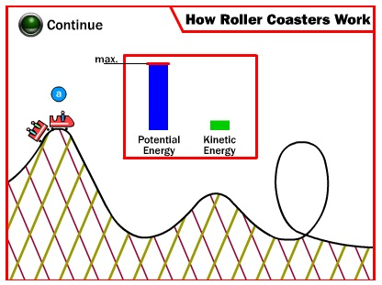
The purpose of the coaster's initial ascent is to build up a sort of reservoir of potential energy. The concept of potential energy, often referred to as energy of position, is very simple. As the coaster gets higher in the air, gravity can pull it down a greater distance. You experience this phenomenon all the time -- think about driving your car, riding your bike or pulling your sled to the top of a big hill. The potential energy you build going up the hill can be released as kinetic energy -- the energy of motion that takes you down the hill.

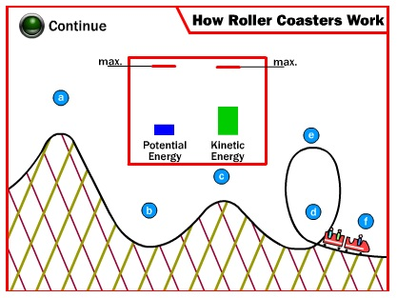
In Figure 2, we can notice that a roller coaster's energy is constantly changing between potential and kinetic energy. At the top of the first lift hill (a), there is maximum potential energy because the train is as high as it gets. As the train starts down the hill, this potential energy is converted into kinetic energy -- the train speeds up. At the bottom of the hill (b), there is maximum kinetic energy and little potential energy. The kinetic energy propels the train up the second hill (c), building up the potential-energy level. As the train enters the loop-the-loop (d), it has a lot of kinetic energy and not much potential energy. The potential-energy level builds as the train speeds to the top of the loop (e), but it is soon converted back to kinetic energy as the train leaves the loop.
Since an object in motion tends to stay in motion (Newton's first law of motion), the coaster car will maintain a forward velocity even when it is moving up the track, opposite the force of gravity. When the coaster ascends one of the smaller hills that follows the initial lift hill, its kinetic energy changes back to potential energy. In this way, the course of the track is constantly converting energy from kinetic to potential and back again.
Figure 2

A roller coaster constantly changes its acceleration and its position to the ground, making the forces of gravity and acceleration interact in many interesting ways. When you plummet down a steep hill, gravity pulls you down while the acceleration force seems to be pulling you up. At a certain rate of acceleration, these opposite forces balance each other out, making you feel a sensation of weightlessness -- the same sensation a skydiver feels in free fall. If the coaster accelerates downward fast enough, the upward acceleration force exceeds the downward force of gravity, making you feel like you're being pulled upward. If you're accelerating up a steep hill, the acceleration force and gravity are pulling in roughly the same direction, making you feel much heavier than normal. If you were to sit on a scale during a roller coaster ride, you would see your "weight" change from point to point on the track. At the top of a hill in a conventional coaster, inertia may carry you up, while the coaster car has already started to follow the track down.

4. Vertical circular motion
Some roller-coasters have loop-the-loop sections, where you travel in a vertical circle, so that you're upside-down at the top (Figure 3). To do this without falling off the track, you have to be traveling at least a particular minimum speed at the top. The critical factor in determining whether you make it completely around is the normal force; if the track has to exert a downward normal force at the top of the track to keep you moving in a circle, you're fine, but if the normal force drops to zero you're in trouble.
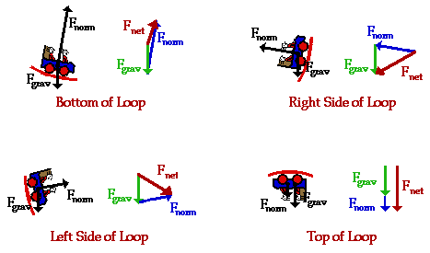
The normal force changes as you travel around a vertical loop; it changes because your speed changes and because your weight has a different effect at each part of the circle. To keep going in a circular path, you must always have a net force equal to mv² / r pointing towards the center of the circle. If the net force drops below the required value, you will veer off the circular path away from the center, and if the net force is more than the required value you will veer off towards the center.

Figure 3
Consider what happens at the bottom of the loop, and compare it to what happens at the top. At the bottom, mg points down and the normal force points up, towards the center of the circle. The normal force is then not simply equal to the weight, but is larger because it must also supply the required centripetal acceleration:
$$F-mg=ma=\frac{mv^{2}}{r} => F=\frac{mv^{2}}{r}+mg$$
At the top of the loop, on the other hand, the normal force and the weight both point towards the center of the circle, so the normal force is less than the weight:
$$F+mg=ma=\frac{mv^{2}}{r} => F=\frac{mv^{2}}{r}-mg$$
If you're going at just the right speed so:

$$\frac{{mv}^{2}}{r}=mg$$

The normal force drops to zero, and you would actually feel weightless for an instant. Faster than this speed and there is a normal force helping to keep you on the circular path; slower and the normal force would go up, which means you'll fall out of the coaster and/or the coaster will fall off the track unless you're strapped in and the coaster is held down to the track.

5. Conclusions
Taking everything into account, we can say that the motion of the roller coasters depends on the physical laws, as it is moved by gravity and momentum. Moreover, it can be noticed that along its movement, each position the roller coaster takes has a specific type of energy (kinetic energy, potential energy or both). In conclusion, not only did we learn how does the roller coaster function, but we also saw a clear example in the usage of physics in day by day life.
6. Bibliography

- http://physics.bu.edu/~duffy/py105/MoreCircular.html
- http://science.howstuffworks.com/engineering/structural/roller-coaster3.htm
- http://www.ux1.eiu.edu/~cfadd/1350/06CirMtn/VertCircle.html

